Use the food web below to answer the questions.

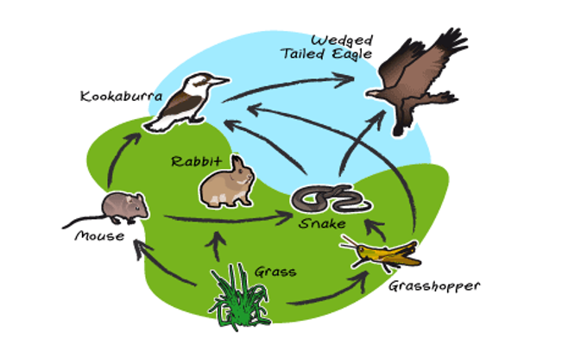

1. Which is a producer? The grass is the producer.
2. Which are the primary consumers? The primary consumer is the grasshopper, rabbit, and mouse.
3. Which are the two secondary consumers? The two secondary consumers are the snake and the Kookaburra.
4. Which is the tertiary consumer? The Wedge Tailed Eagle is the tertiary consumer.
5. Which is the top predator? The top predator is the Wedge Tailed Eagle.
6. What is one whole food chain that you see in the food web?

**The grass to the mouse to the kookaburra and finally to the wedge tailed eagle.**